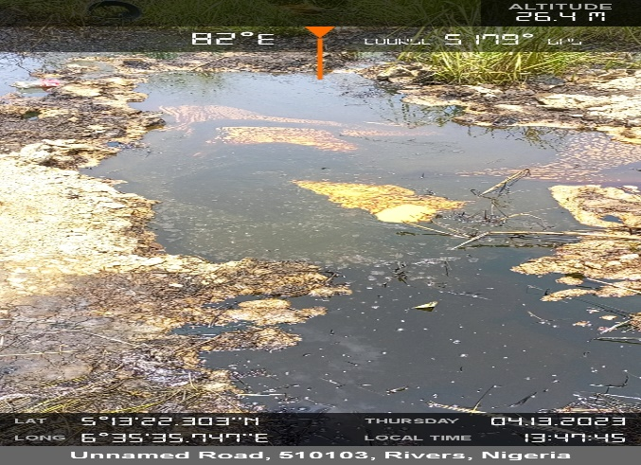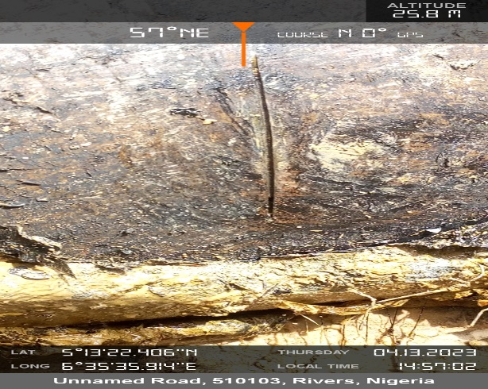
Figure 1 Arrow showing Disturbed / Impacted Area Figure 2 Arrow showing Spill point

